Test Report

Pharmaceutical Management System

Team 10

Member Name | Member Roll # | Primary Responsibility
Ghayyur Ali | 12L-4276 | Add Branch Manager
Usama Saqib | 15L-4064 | Request Medicine
Usman Majied | 15L-4033 | Sell Medicine
Muhammad Faiq | 15L-4266 | Edit Salesman

Fig1: Request Medicine Flowchart

Identifier | TC-1
Priority | Medium
Type of Testing | Boundary Testing
Short description | Request Medicine is tested for invalid input
Pre-condition(s) | - Branch Manager should be logged in  - Requested Medicine should be in current list of medicines
Input data | -1, 0, 1.5, ‘abc’
Expected result(s) | Error: Invalid input
Post-condition(s) | Error: Invalid input
Table 1: TC-1

Identifier | TC-2
Priority | Medium
Type of Testing | Boundary Testing
Short description | Request Medicine is tested for valid input
Pre-condition(s) | - Branch Manager should be logged in  - Requested Medicine should be in current list of medicines
Input data | 100
Expected result(s) | Request sent successfully
Post-condition(s) | Request sent successfully
Table 2: TC-2

Identifier | TC-3
Priority | Medium
Type of Testing | Branch Coverage
Short description | Request Medicine is tested
Pre-condition(s) | - Branch Manager should be logged in  - Requested Medicine should be in current list of medicines
Input data | MedList size = 10  Quantity = 10  C = 1
Expected result(s) | A,B,E,F,G,H,I,J,K,L,M,N,O,Q
Post-condition(s) | A,B,E,F,G,H,I,J,K,L,M,N,O,Q
Table 3: TC-3

Identifier | TC-4
Priority | Medium
Type of Testing | Branch Coverage
Short description | Request Medicine is tested
Pre-condition(s) | - Branch Manager should be logged in  - Requested Medicine should be in current list of medicines
Input data | MedList size = 0
Expected result(s) | A,B,C,U,T
Post-condition(s) | A,B,C,U,T
Table 4: TC-4

Identifier | TC-5
Priority | Medium
Type of Testing | Branch Coverage
Short description | Request Medicine is tested
Pre-condition(s) | - Branch Manager should be logged in  - Requested Medicine should be in current list of medicines
Input data | MedList size = 10  Quantity = -10  C=10
Expected result(s) | A,B,E,F,G,S,D,E,F,G,H,I,J,K,L,M,N,O,Q
Post-condition(s) | A,B,E,F,G,S,D,E,F,G,H,I,J,K,L,M,N,O,Q
Table 5: TC-5

Identifier | TC-6
Priority | Medium
Type of Testing | Branch Coverage
Short description | Request Medicine is tested
Pre-condition(s) | - Branch Manager should be logged in  - Requested Medicine should be in current list of medicines
Input data | MedList size = 10  Quantity = -10  C=-1
Expected result(s) | A,B,E,F,G,S,D,E,F,G,H,I,J,K,L,M,N,P,R
Post-condition(s) | A,B,E,F,G,S,D,E,F,G,H,I,J,K,L,M,N,P,R
Table 6: TC-6

Identifier | TC-7
Priority | Medium
Type of Testing | Path Coverage
Short description | Request Medicine is tested
Pre-condition(s) | - Branch Manager should be logged in  - Requested Medicine should be in current list of medicines
Input data | MedList size = 10  Quantity = 10  C = 1
Expected result(s) | A,B,E,F,G,H,I,J,K,L,M,N,O,Q
Post-condition(s) | A,B,E,F,G,H,I,J,K,L,M,N,O,Q
Table 7: TC-7

Identifier | TC-8
Priority | Medium
Type of Testing | Path Coverage
Short description | Request Medicine is tested
Pre-condition(s) | - Branch Manager should be logged in  - Requested Medicine should be in current list of medicines
Input data | MedList size = 0
Expected result(s) | A,B,C,U,T
Post-condition(s) | A,B,C,U,T
Table 8: TC-8

Identifier | TC-9
Priority | Medium
Type of Testing | Path Coverage
Short description | Request Medicine is tested
Pre-condition(s) | - Branch Manager should be logged in  - Requested Medicine should be in current list of medicines
Input data | MedList size = 10  Quantity = -10  C=10
Expected result(s) | A,B,E,F,G,S,D,E,F,G,H,I,J,K,L,M,N,O,Q
Post-condition(s) | A,B,E,F,G,S,D,E,F,G,H,I,J,K,L,M,N,O,Q
Table 9: TC-9

Identifier | TC-10
Priority | Medium
Type of Testing | Path Coverage
Short description | Request Medicine is tested
Pre-condition(s) | - Branch Manager should be logged in  - Requested Medicine should be in current list of medicines
Input data | MedList size = 10  Quantity = -10  C=-1
Expected result(s) | A,B,E,F,G,S,D,E,F,G,H,I,J,K,L,M,N,P,R
Post-condition(s) | A,B,E,F,G,S,D,E,F,G,H,I,J,K,L,M,N,P,R
Table 10: TC-10

Identifier | TC-11
Priority | Medium
Type of Testing | Loop Boundary Testing
Short description | Request Medicine is tested
Pre-condition(s) | - Branch Manager should be logged in  - Requested Medicine should be in current list of medicines
Input data | MedList size = 0
Expected result(s) | A,B,C,U,T
Post-condition(s) | A,B,C,U,T
Table 11: TC-11

Identifier | TC-12
Priority | Medium
Type of Testing | Loop Boundary Testing
Short description | Request Medicine is tested
Pre-condition(s) | - Branch Manager should be logged in  - Requested Medicine should be in current list of medicines
Input data | MedList size = 10  Quantity = -10  C=10
Expected result(s) | A,B,E,F,G,S,D,E,F,G,H,I,J,K,L,M,N,O,Q
Post-condition(s) | A,B,E,F,G,S,D,E,F,G,H,I,J,K,L,M,N,O,Q
Table 13: TC-13

Identifier | TC-14
Priority | Medium
Type of Testing | Loop Boundary Testing
Short description | Request Medicine is tested
Pre-condition(s) | - Branch Manager should be logged in  - Requested Medicine should be in current list of medicines
Input data | MedList size = 10  Quantity = -10  C=-1
Expected result(s) | A,B,E,F,G,S,D,E,F,G,H,I,J,K,L,M,N,P,R
Post-condition(s) | A,B,E,F,G,S,D,E,F,G,H,I,J,K,L,M,N,P,R
Table 14: TC-14
Identifier | TC-15
Priority | Medium
Type of Testing | Statement Coverage
Short description | Request Medicine is tested
Pre-condition(s) | - Branch Manager should be logged in  - Requested Medicine should be in current list of medicines
Input data | MedList size = 10  Quantity = -10  C=-1
Expected result(s) | A,B,E,F,G,S,D,E,F,G,H,I,J,K,L,M,N,P,R
Post-condition(s) | A,B,E,F,G,S,D,E,F,G,H,I,J,K,L,M,N,P,R
Table 15: TC-15
Identifier | TC-16
Priority | Medium
Type of Testing | Statement Coverage
Short description | Request Medicine is tested
Pre-condition(s) | - Branch Manager should be logged in  - Requested Medicine should be in current list of medicines
Input data | MedList size = 10  Quantity = -10  C=1
Expected result(s) | A,B,E,F,G,S,D,E,F,G,H,I,J,K,L,M,N,O,Q
Post-condition(s) | A,B,E,F,G,S,D,E,F,G,H,I,J,K,L,M,N,O,Q
Table 16: TC-16

Identifier | TC-17
Priority | Medium
Type of Testing | Statement Coverage
Short description | Request Medicine is tested
Pre-condition(s) | - Branch Manager should be logged in  - Requested Medicine should be in current list of medicines
Input data | MedList size = 1  Quantity = -10
Expected result(s) | A,B,E,F,G,S,D,C,U,T
Post-condition(s) | A,B,E,F,G,S,D,C,U,T
Table 17: TC-17

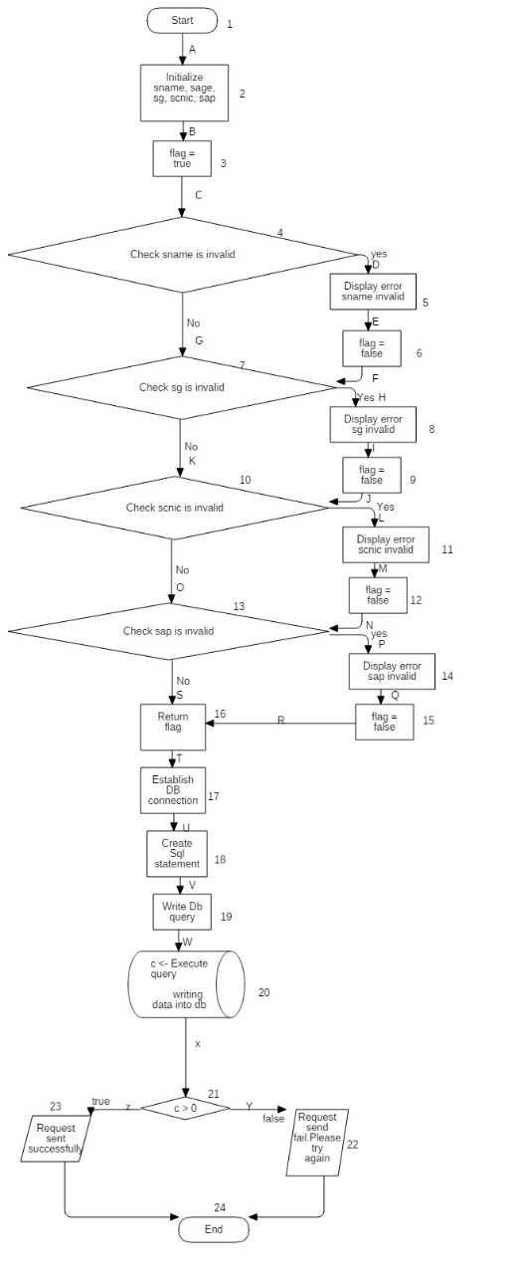

Fig 2: Edit Salesman Flow chart
Identifier | TC-18
Priority | Medium
Type of testing | Boundary testing
Short Description | Change Salesman Profile is tested for invalid inputs
Pre-condition(s) | 1: Branch manager should be logged in  2: Branch manager should request for changing salesman Profile
Input Data | *Null entered in all of the fields *
Expected Result(s) | Error: “Error in name..” “Error in sg ” “Error in scnic”
Post-condition(s) | Error: “Error in name..” “Error in sg ” “Error in scnic”
Table 18: TC-18

Identifier | TC-19
Priority | Medium
Type of testing | Boundary testing
Short Description | Change Salesman Profile is tested for Valid inputs
Pre-condition(s) | 1: Branch manager should be logged in  2: Branch manager should request for changing salesman Profile
Input Data | Faiq, 12, 35202-8193737-9, 34
Expected Result(s) | Updated successfully
Post-condition(s) | Updated successfully
Table 19: TC-19

Identifier | TC-20
Priority | Medium
Type of testing | Branch Coverage
Short Description | Change Salesman Profile is checked for the branch in which all inputs will be valid and no error condition will be triggered, in order to check edged from left side. i.e 1A-2B-3C-4G-7K-10O-13S-16T-17U-18V-19W-20X-21Z
Pre-condition(s) | 1: Branch manager should be logged in  2: Branch manager should request for changing salesman Profile
Input Data | Faiq, 12, 35202-8193737-9, 34
Expected Result(s) | Updated successfully
Post-condition(s) | Updated successfully
Table 20: TC-20

Identifier | TC-21
Priority | Medium
Type of testing | Branch Coverage
Short Description | Change Salesman Profile is checked for the branch in which all inputs will be invalid and all error condition will be triggered so to check the right-side edges. i.e 1A-2B-3C-4D-5E-6F-7H-8I-9J-10L-11M-12N-13P-14Q-15R-16T-17U-18V-19W-20X-21Y
Pre-condition(s) | 1: Branch manager should be logged in  2: Branch manager should request for changing salesman Profile
Input Data | *Null entered in all of the fields *
Expected Result(s) | Error: “Error in name..” “Error in sg ” “Error in scnic”
Post-condition(s) | Error: “Error in name..” “Error in sg ” “Error in scnic”
Table 21: TC-21

Identifier | TC-22
Priority | Medium
Type of testing | Path Coverage
Short Description | Change Salesman Profile is checked for different paths to check legality of every path. In this case it is 1A-2B-3C-4D-5E-6F-7K-10L-11M-12N-13S-16T-17U-18V-19W-20X-21Y
Pre-condition(s) | 1: Branch manager should be logged in  2: Branch manager should request for changing salesman Profile
Input Data | 31 , 42 , 35202-8193737-9, faiq
Expected Result(s) | Error: “Error in name”, “Error in sap”
Post-condition(s) | Error: “Error in name”, “Error in sap”
Table 22: TC-22

Identifier | TC-23
Priority | Medium
Type of testing | Path Coverage
Short Description | Change Salesman Profile is checked for different paths to check legality of every path. In this case it is 1A-2B-3C-4G-7H-8I-9J-100-13P-14Q-15R-16T-17U-18V-19W-20X-21Y
Pre-condition(s) | 1: Branch manager should be logged in  2: Branch manager should request for changing salesman Profile
Input Data | faiq , asfas , 34, fsaf
Expected Result(s) | Error: “Error in cnicn”, “Error in sg”
Post-condition(s) | Error: “Error in cnicn”, “Error in sg”
Table 23: TC-23

Identifier | TC-24
Priority | Medium
Type of testing | Path Coverage
Short Description | Change Salesman Profile is checked for different paths to check legality of every path. In this case it is 1A-2B-3C-4G-7K-10O-13S-16T-17U-18V-19W-20X-21Z
Pre-condition(s) | 1: Branch manager should be logged in  2: Branch manager should request for changing salesman Profile
Input Data | Faiq, 12, 35202-8193737-9, 34
Expected Result(s) | Updated successfully
Post-condition(s) | Updated successfully
Table 24: TC-24

Identifier | TC-25
Priority | Medium
Type of testing | Path coverage
Short Description | Change Salesman Profile is checked for different paths to check legality of every path. In this case it is 1A-2B-3C-4D-5E-6F-7H-8I-9J-10L-11M-12N-13P-14Q-15R-16T-17U-18V-19W-20X-21Y
Pre-condition(s) | 1: Branch manager should be logged in  2: Branch manager should request for changing salesman Profile
Input Data | *Null entered in all of the fields *
Expected Result(s) | Error: “Error in name..” “Error in sg ” “Error in scnic”
Post-condition(s) | Error: “Error in name..” “Error in sg ” “Error in scnic”
Table 25: TC-25

Identifier | TC-26
Priority | Medium
Type of testing | Statement coverage
Short Description | Change Salesman Profile is checked for every statement so to verify either every statement is executing properly or not.
Pre-condition(s) | 1: Branch manager should be logged in  2: Branch manager should request for changing salesman Profile
Input Data | *Null entered in all of the fields *
Expected Result(s) | Error: “Error in name..” “Error in sg ” “Error in scnic”
Post-condition(s) | Error: “Error in name..” “Error in sg ” “Error in scnic”

Table 26: TC-26

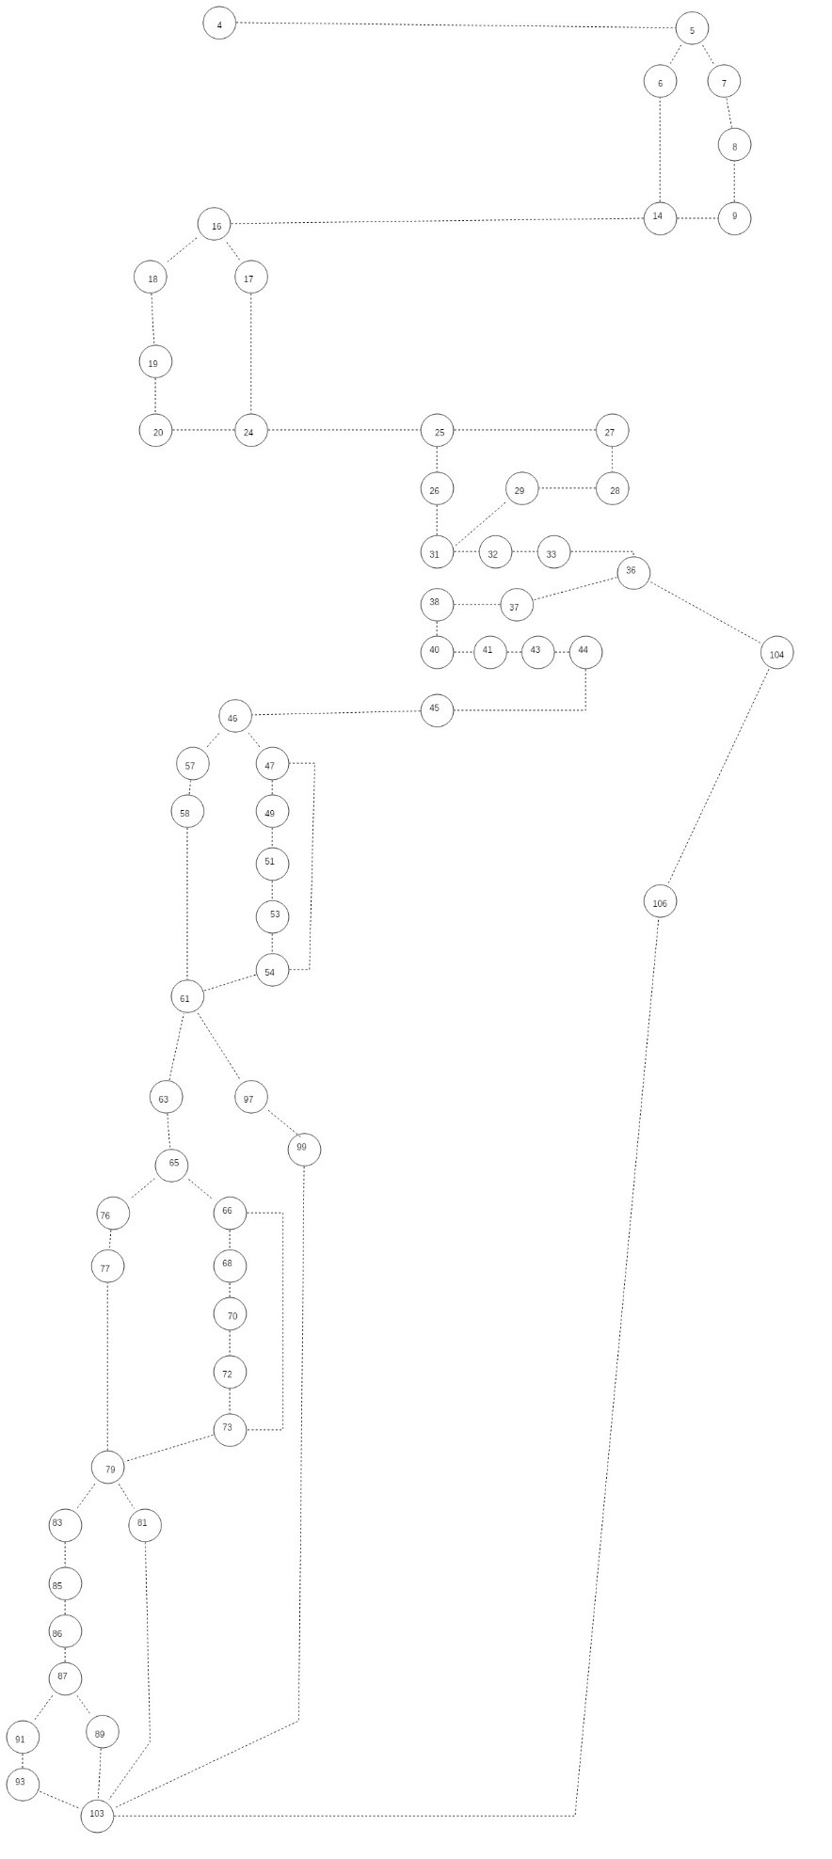

Fig 3: Add Branch Manager Control Flow Diagram

Identifier | TC-27
Priority | High
TC Name | Statement Coverage
Short description | Here we execute each and every statement of the module under testing. Currently we are testing the “Add Branch Manager” module which basically assigns the branch manager to a branch after entering the required details. It is accessible to General Manager only.
Pre-condition(s) | Add Branch Manager page is opened and user is logged in.
Input data | We fill in the required fields for branch code, salary and other details.
Expected result(s) | The branch manager is successfully added.
Post-condition(s) | Message window is displayed.
Table 27: TC-27

Identifier | TC-28
Priority | High
TC Name | Branch Coverage
Short description | Here we verify each and every decision branch of the module under testing. Currently we are testing the “Add Branch Manager” module which basically assigns the branch manager to a branch after entering the required details. It is accessible to General Manager only.
Pre-condition(s) | Add Branch Manager page is opened and user is logged in.
Input data | We fill in the required fields for branch code, salary and other details.
Expected result(s) | The branch manager is successfully added.
Post-condition(s) | Message window is displayed.
Table 28: TC-28

Identifier | TC-29
Priority | High
TC Name | Path Coverage
Short description | Here we cover each and every path inside the module under testing. Currently we are testing the “Add Branch Manager” module which basically assigns the branch manager to a branch after entering the required details. It is accessible to General Manager only.
Pre-condition(s) | Add Branch Manager page is opened and user is logged in.
Input data | We fill in the required fields for branch code, salary and other details.
Expected result(s) | The branch manager is successfully added.
Post-condition(s) | Message window is displayed.
Table 29: TC-29

Identifier | TC-30
Priority | High
TC Name | Loop Boundary Coverage
Short description | Here we verify each and every loop inside the module under testing. Currently we are testing the “Add Branch Manager” module which basically assigns the branch manager to a branch after entering the required details. It is accessible to General Manager only.
Pre-condition(s) | Add Branch Manager page is opened and user is logged in.
Input data | We fill in the required fields for branch code, salary and other details.
Expected result(s) | The branch manager is successfully added.
Post-condition(s) | Message window is displayed.
Table 30: TC-30

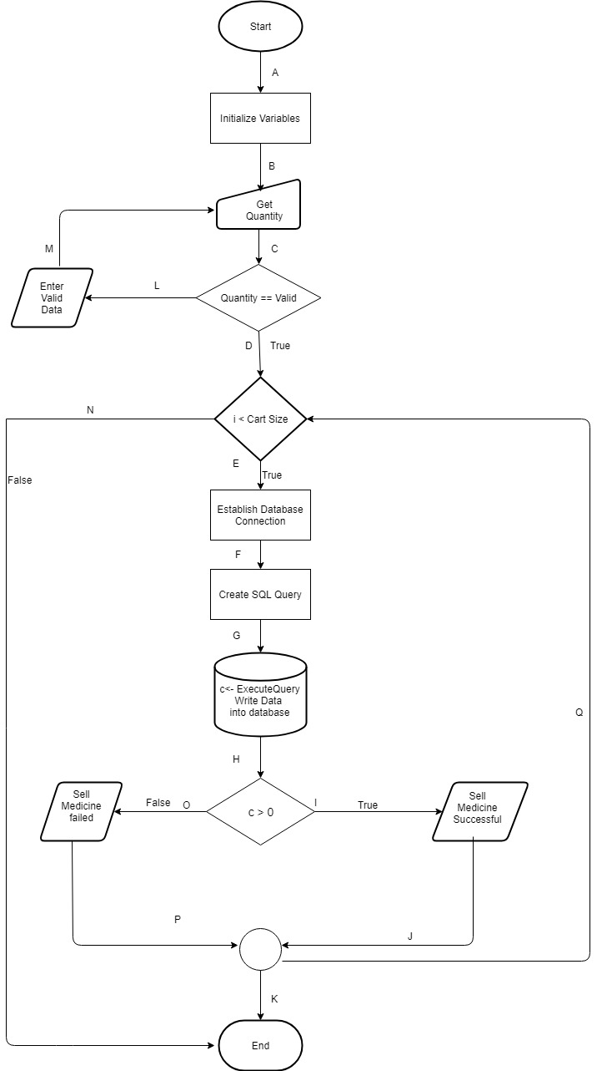

Fig 4: Sell Medicine Flowchart
Identifier | TC-31
Priority | High
Type of Testing | Boundary
Short description | Sell Medicine is tested
Pre-condition(s) | - Salesman should be logged in  - Medicine inventory should be displayed to the salesman
Input data | -1, 0, 10.5, any value above available quantity
Expected result(s) | Cannot register the sale
Post-condition(s) | Cannot register the sale
Table 31: TC-31

Identifier | TC-32
Priority | High
Type of Testing | Boundary
Short description | Sell Medicine is tested
Pre-condition(s) | - Salesman should be logged in  - Medicine inventory should be displayed to the salesman
Input data | Any value within the available amount
Expected result(s) | Added to card
Post-condition(s) | Added to card
Table 32: TC-32

Identifier | TC-33
Priority | High
Type of Testing | Branch Coverage
Short description | Sell Medicine is tested
Pre-condition(s) | - Salesman should be logged in  - Medicine inventory should be displayed to the salesman
Input data | Quantity higher than the available quantity
Expected result(s) | A-B-C-L-M
Post-condition(s) | A-B-C-L-M

Table 33: TC-33

Identifier | TC-34
Priority | High
Type of Testing | Branch Coverage
Short description | Sell Medicine is tested for valid input
Pre-condition(s) | - Salesman should be logged in  - Medicine inventory should be displayed to the salesman
Input data | Quantity is valid, i.e. within the available amount, i < Cart Size , c > 0
Expected result(s) | A-B-C-D-E-F-G-H-I-J-K
Post-condition(s) | A-B-C-D-E-F-G-H-I-J-K
Table 34: TC-34

Identifier | TC-35
Priority | High
Type of Testing | Branch Coverage
Short description | Sell Medicine is tested for valid input
Pre-condition(s) | - Salesman should be logged in  - Medicine inventory should be displayed to the salesman
Input data | Quantity is valid, i.e. within the available amount, i > Cart Size
Expected result(s) | A-B-C-D-N
Post-condition(s) | A-B-C-D-N
Table 35: TC-35

Identifier | TC-36
Priority | High
Type of Testing | Branch Coverage
Short description | Sell Medicine is tested for valid input
Pre-condition(s) | - Salesman should be logged in  - Medicine inventory should be displayed to the salesman
Input data | Quantity is valid, i.e. within the available amount, i < Cart Size, c < 0
Expected result(s) | A-B-C-D-E-F-G-H-0-P-K
Post-condition(s) | A-B-C-D-E-F-G-H-0-P-K
Table 36: TC-36

Identifier | TC-37
Priority | High
Type of Testing | Path Coverage
Short description | Sell Medicine is tested for valid input
Pre-condition(s) | - Salesman should be logged in  - Medicine inventory should be displayed to the salesman
Input data | Quantity is valid, i.e. within the available amount, i < Cart Size, c < 0
Expected result(s) | A-B-C-L-M
Post-condition(s) | A-B-C-L-M
Table 37: TC-37

Identifier | TC-38
Priority | High
Type of Testing | Path Coverage
Short description | Sell Medicine is tested for valid input
Pre-condition(s) | - Salesman should be logged in  - Medicine inventory should be displayed to the salesman
Input data | Quantity is valid, i.e. within the available amount, i < Cart Size, c < 0
Expected result(s) | A-B-C-D-E-F-G-H-I-J-K
Post-condition(s) | A-B-C-D-E-F-G-H-I-J-K
Table 38: TC-38

Identifier | TC-39
Priority | High
Type of Testing | Path Coverage
Short description | Sell Medicine is tested for valid input
Pre-condition(s) | - Salesman should be logged in  - Medicine inventory should be displayed to the salesman
Input data | Quantity is valid, i.e. within the available amount, i > Cart Size
Expected result(s) | A-B-C-D-N
Post-condition(s) | A-B-C-D-N
Table 39: TC-39

Identifier | TC-40
Priority | High
Type of Testing | Path Coverage
Short description | Sell Medicine is tested
Pre-condition(s) | - Salesman should be logged in  - Medicine inventory should be displayed to the salesman
Input data | Quantity is valid, i.e. within the available amount, i < Cart Size, c < 0
Expected result(s) | A-B-C-D-E-F-G-H-0-P-K
Post-condition(s) | A-B-C-D-E-F-G-H-0-P-K
Table 40: TC-40

Identifier | TC-41
Priority | High
Type of Testing | Statement Coverage
Short description | Sell Medicine is tested
Pre-condition(s) | - Salesman should be logged in  - Medicine inventory should be displayed to the salesman
Input data | Quantity is valid, i.e. within the available amount, i < Cart Size , c > 0
Expected result(s) | A-B-C-D-E-F-G-H-I-J-K
Post-condition(s) | A-B-C-D-E-F-G-H-I-J-K
Table 41: TC-41

Identifier | TC-42
Priority | High
Type of Testing | Statement Coverage
Short description | Sell Medicine is tested
Pre-condition(s) | - Salesman should be logged in  - Medicine inventory should be displayed to the salesman
Input data | Quantity is valid, i.e. within the available amount, i < Cart Size, c < 0
Expected result(s) | A-B-C-D-E-F-G-H-0-P-K
Post-condition(s) | A-B-C-D-E-F-G-H-0-P-K
Table 42: TC-42

Identifier | TC-43
Priority | High
Type of Testing | Statement Coverage
Short description | Sell Medicine is tested
Pre-condition(s) | - Salesman should be logged in  - Medicine inventory should be displayed to the salesman
Input data | Quantity higher than the available quantity
Expected result(s) | A-B-C-L-M
Post-condition(s) | A-B-C-L-M
Table 43: TC-43

